G9 Social Network

This project is intended to unite the small community of Computer Science by an electronic mean of communication.

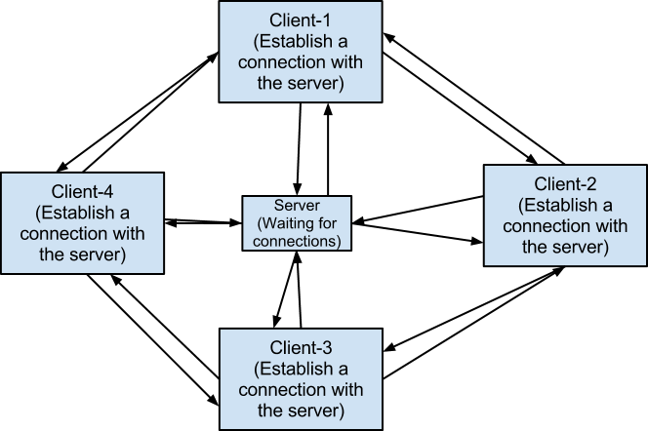

The server will be waiting until a client connect, but the server must verify that the client exist in the database. When such a connection is established, the server will send back a list of connected client that are part of the contact list of the client connected. From this connection list, the client can open a connection where it can send messages or image.

