Database review assignment, December 2013
For the following application, write informal pseudo-code using these functions (methods):
- dbopen(...) Open a connection to a database, which will be used for all other operations.
- query(sql, params) returns a ResultSet (a table), where sql is an sql statement with placeholders (either ?, $1, or %s) and params is a list of data values, as many as there are placeholders.
- Or else you can use (sql and params as above)
- statement = prepare(sql)
- result = statement.exec (params) – can be done several times with different data. Returns FALSE in case of error, probably some invalid data.
- With a result, you can use
- result.nextrow() -- returns an array, or FALSE if no more rows
- result.fetch(row, col) -- returns one value
- or error() -- will print out appropriate error message, then you can retry or exit.
- You may also make up your own functions, and tell me what they do, if this is inadequate.
In any case, I want to see correct SQL, and I should be able to tell from indentation (or { }) the extent of loops and if statements.
- Indicate where input is needed, but don't concern yourself about how it will be provided.

The problem:
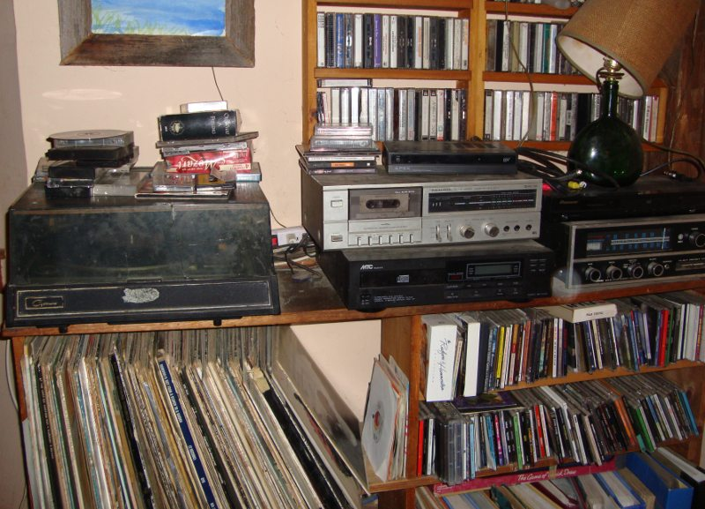
I have a collection of recordings in several formats, as seen in the picture (also video tapes, not shown). I am willing to lend them to friends, but I want to keep track of who has what.

I would like an application for my computer that would work as follows:

Should a friend wish to borrow some of these things, I would first enter my friend's name. Then
- If the friend is in the database, produce a list of what they've already borrowed.
- Else, enter also their phone and email.
Then, a loop to record the identifying information about each item, and insert that into the database, and also the fact that this friend borrowed it, on this date. Note that I do not believe I would ever “put all this stuff into the computer,” not until it's borrowed.
(Deleting records upon return, and using the possibility that later some recordings will be already entered, will be left to the future.)

What to do:
- Develop a relational schema, perhaps starting with an E/R or Object-oriented model, show keys.
- Do the pseudo-code for the program, being very careful about the SQL needed.
Not to be handed in. Solution available on Wednesday.

